Chapter 19, Problem 99.

Assume that the two circuits in Fig.19.135 are equivalent. The parameters of the two circuits must be equal. Using this factor and the z parameters, derive Eqs.(9.67) and (9.68).

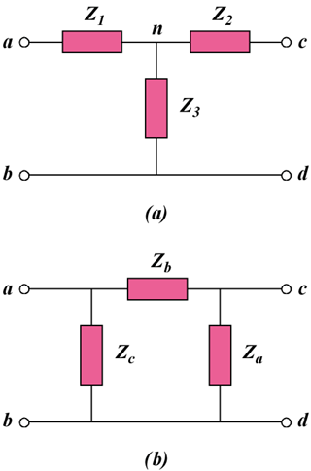

Figure 19.135
For Prob. 19.99.

